11/1/20

**Why become a member?**

*Have you ever ask yourself “What can I do to help our law enforcement and show them that the community really cares”*

*This is just one way of doing just that.*

*Not only is law enforcement a dangerous job, it also is one that is taking a toll on us personally.*

*The pressures of law enforcement have moved one of the leading causes of death from gunfire to suicide.*

*Law enforcement departments and offices can not combat crime and keep the community safe alone. The FOP is no different and has to have the support of the community in order to provide insurance and benefits to the Officers and also give back to the community through our outreach programs.*

*Legislative involvement:*

*We have lobbyist at the Capital and the White House, however it is the citizens contacting their representatives in getting laws passed that support the law enforcement profession which will help in keeping our communities safe.*

*Our local lodge members are volunteers and receive no salary. They serve for the betterment of Law Enforcement and the communities we serve.*

*Working together for a safer community.*

**What is an Associate Member**

Associate members are civilian supporters of the law enforcement community.

They are members of society that have an interest in the future of DeKalb and the safety and security of our community. They are individuals of high moral character with focus on bettering the community and all law enforcement in DeKalb. Associate members are not eligible to vote or hold office in the lodge, however their opinions/suggestions are welcomed.

**Who can be an Associate Member.**

Associate members consist of friends, individual / professional citizens, businesses, and public safety support personnel 18 years of age or older.

Can not have any felony, sexual, or obstruction of law enforcement arrest.

Can not be a member or affiliated with any anti-government, sovereign citizen, or any other group that do not agree with law enforcement or views.

Benefits:

**Individual**

* *Associate membership card*
* *Associate member decals*
* *Associate member certificate*
* *Discount rental of the lodge. As an Associate member in good standing, you are eligible to rent the lodge at a reduced rate. $500+ for associate members ($1000+ for non-members). Our lodge is a great private setting for birthday parties, anniversary celebrations, family reunions, training, etc.*

**Business**

* *Associate membership card*
* *Associate member decals*
* *Associate member certificate*
* *Listing on our website. This is a way of highlighting your business as a law enforcement and community supporter*
* *Discount rental of the lodge. As an Associate member in good standing, you are eligible to rent the lodge at a reduced rate. $500+ for members ($1000+ for non-members). Our lodge is a great setting for birthday parties, anniversary celebrations, family reunions, training, etc.*

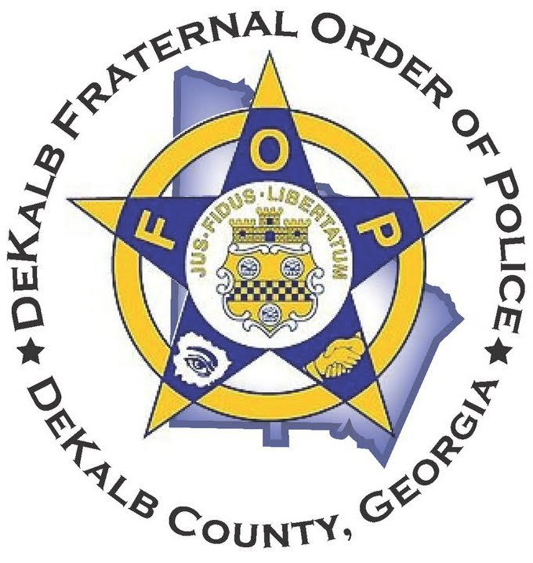

**About the FOP**

Founded in 1915, the Fraternal Order of Police is the world's largest organization of sworn law enforcement officers, with more than 330,000 members in more than 2,100 lodges. We are the voice of those who dedicate their lives to protecting and serving our communities. We are committed to improving the working conditions of law enforcement officers and the safety of those we serve through education, legislation, information, community involvement, and employee representation. No one knows the dangers and the difficulties faced by today's police officers better than another officer, and no one knows police officers better than the FOP.

*The Dekalb Lodge 10 was chartered on January 2, 1970. We are celebrating our 50th year.*

*Here are just some of the benefits we provide to our law enforcement members:*

* *life and accidental death or dismemberment insurance.*
* *Discount Home and auto insurance*
* *Discount Travel benefits*
* *Free college (associates degree)*
* *College discounts to many universities*
* *Scholarships*

***Some of the lodge’s Accomplishments:***

*The most common legislation the Georgia FOP introduced and was able to get passed the “blue alert” bill which uses DOT message boards when a law enforcement Officer is severely injured or killed.*

*Started a charitable foundation and purchased a house that we call “My Brother’s House” that we use like a Ronald McDonald house for Officer’s families to use in time of need. It is mainly for out of town families while officers are receiving treatment at Sheppard Center,Grady, or other local hospitals.*

*Every year we take at least 50 less fortunate, at risk children shopping(except 2020/ COVID-19). We pair them up with Officers from every agency that wishes to participate to go shopping and spent approximately $200 each. We then take them to the lodge facility for food, fellowship with the Officers and of course Santa Claus.*

*We also assist from time to time with toys, candy, and school supplies throughout the year as needs arise.*

*Local lodge members are volunteers and receive no salary. They serve for the betterment of Law Enforcement and the communities we serve.*

**Associate Member Application**

Name __________________________

Address _________________________

City, State, Zip _________________

Cell: ___________________________

Email: __________________________

Date of birth _____________________

Type of membership

**Individu**al-----------------$60 yr.

Civilian, Civilian Public

Safety, Sworn 911 Operator

**Small Business**----------$250 yr.

(less than 15 employees)

**Large Business**----------$500 yr.

(16 or more employees)

Additional Donations amount $_ _

Payment options: *Circle one*

Check/money order / Paypal-www.dekalbfop

I, the undersigned, certify that I am an American citizen and good moral character. I do hereby apply for Associate Membership in the Dekalb FOP Lodge 10. I solemnly swear or affirm that I am 18 years of age or older, a citizen of good repute of the United States of America,that I have not had any felony, sexual, or obstruction of law enforcement arrest, that I am not a member or affiliated with any anti-government, sovereign citizen, or any other group that do not agree with law enforcement or views.

Signature __________________Date ______

**Fraternal Order**

**Of Police**

**DeKalb Lodge #10**

**1238 Ridge Avenue**

**Stone Mountain,**

**Georgia 30083**

[***www.dekalbfop.org***](http://www.dekalbfop.org)

***Associate Member***

***Application***